Unified Classroom Gradebook
ASSIGNMENT
- Uses your local Student Information System (SIS) standards.
  - These standards are usually your report card standards.
- Standards can be attached, but are not required.
  - When standards are associated to an assignment, the standards scores can be set to Auto-Calculate.

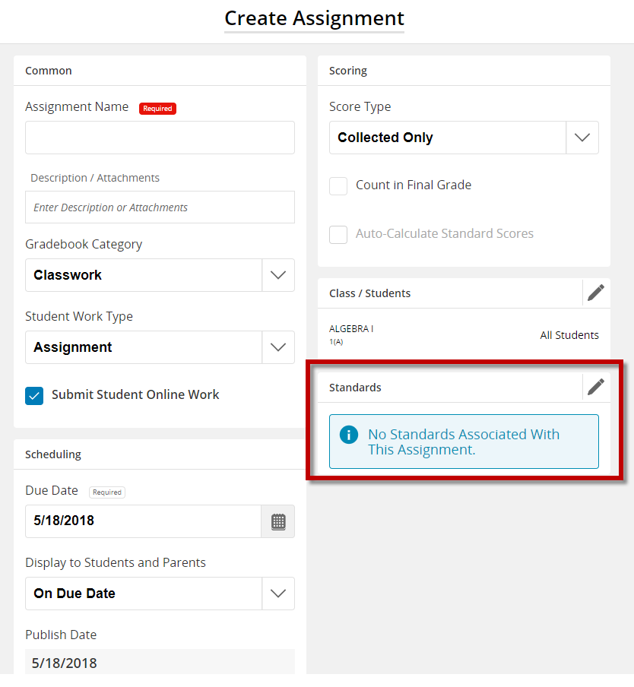

These standards are the standards that appear on the Dashboard, the Standards Progress page, and usually the Report Card.

Unified Classroom Library
ASSESSMENT
- Uses both local Student Information System standards, as well as, external standards from Academic Benchmark.
- When creating an Item, you are required to attach at least one standard.

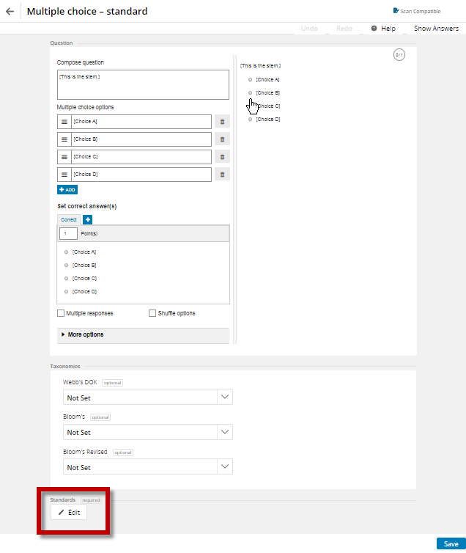
- Currently there is no reporting available for these standards.
  - To see how students scored on these standards, you can view the results on the Results tab of the Proctor Assessment page.
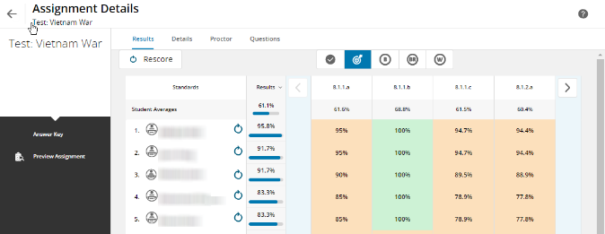
NOTE: At this time, any standard that is assigned to an Assessment Item will NOT flow into the Gradebook. It needs to be attached on the actual assignment.

